|  |  |  |
| --- | --- | --- |
| **LAB221 Assignment** | **Type:** | **Short Assignment** |
| **Code:** | **J2.S.P0114** |
| **LOC:** | **70** |
| **Slot(s):** | **2** |

**Title**

Create database

**Background Context**

NA

**Program Specifications**

Use swing library to create a program interact with MS SQL database.

Main functions described as below:

***Function details:***

1. Create a new database name “FU_DB”
2. Create a table name “Stocks” with fields:

* StockID: type is integer
* StockName: string
* Address: string
* DateAvailable: Date
* Note: string

1. Insert into “Stocks” table 5 records
2. Display all 5 records on the form

***Expectation of User interface:***

The screen should be as:

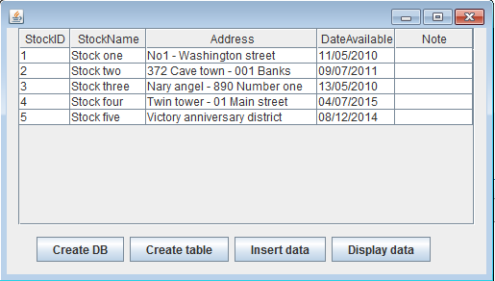

**Guidelines**